Abap Employee details using alv

Coding:
TYPE-POOLS slis.
tables zempl.
select-OPTIONS s_empid FOR zempl-empid.
data v TYPE zcomp-compid.
TYPES: BEGIN OF ty,
empid TYPE zempl-empid,
empname TYPE zempl-empname,
compid TYPE zempl-compid,
jobrole TYPE zempl-jobrole,
doj TYPE zempl-doj,
address TYPE zempl-address,
END OF ty.
data: wa TYPE ty,
it TYPE TABLE of ty.
data: it_c TYPE TABLE of zcomp,
wa_c LIKE LINE OF it_c.
SELECT empid empname compid jobrole doj address from zempl into TABLE it where empid in s_empid.
data: it_fc TYPE slis_t_fieldcat_alv,
wa_fc like LINE OF it_fc.
wa_fc-fieldname = 'empid'.
wa_fc-col_pos = '1'.
wa_fc-seltext_m = 'Emp.Id'.
APPEND wa_fc to it_fc.
clear wa_fc.
wa_fc-fieldname = 'empname'.
wa_fc-col_pos = '2'.
wa_fc-seltext_m = 'Emp.Name'.
APPEND wa_fc to it_fc.
clear wa_fc.
wa_fc-fieldname = 'compid'.
wa_fc-col_pos = '3'.
wa_fc-seltext_m = 'Comp.Id'.
APPEND wa_fc to it_fc.
clear wa_fc.
wa_fc-fieldname = 'jobrole'.
wa_fc-col_pos = '4'.
wa_fc-seltext_m = 'Job.Role'.
APPEND wa_fc to it_fc.
clear wa_fc.
wa_fc-fieldname = 'doj'.
wa_fc-col_pos = '5'.
wa_fc-seltext_m = 'Date.of.Joining'.
APPEND wa_fc to it_fc.
clear wa_fc.
wa_fc-fieldname = 'address'.
wa_fc-col_pos = '6'.
wa_fc-seltext_m = 'Address'.
APPEND wa_fc to it_fc.
clear wa_fc.
data: it_e TYPE slis_t_event,
wa_e like LINE OF it_e.
wa_e-name = 'USER_COMMAND'.
wa_e-form = 'UC'.
APPEND wa_e to it_e.
CALL FUNCTION 'REUSE_ALV_LIST_DISPLAY'
EXPORTING
* I_INTERFACE_CHECK = ' '
* I_BYPASSING_BUFFER =
* I_BUFFER_ACTIVE = ' '
I_CALLBACK_PROGRAM = sy-cprog
* I_CALLBACK_PF_STATUS_SET = ' '
* I_CALLBACK_USER_COMMAND = ' '
* I_STRUCTURE_NAME =
* IS_LAYOUT =
IT_FIELDCAT = it_fc
* IT_EXCLUDING =
* IT_SPECIAL_GROUPS =
* IT_SORT =
* IT_FILTER =
* IS_SEL_HIDE =
* I_DEFAULT = 'X'
* I_SAVE = ' '
* IS_VARIANT =
IT_EVENTS = it_e
* IT_EVENT_EXIT =
* IS_PRINT =
* IS_REPREP_ID =
* I_SCREEN_START_COLUMN = 0
* I_SCREEN_START_LINE = 0
* I_SCREEN_END_COLUMN = 0
* I_SCREEN_END_LINE = 0
* IR_SALV_LIST_ADAPTER =
* IT_EXCEPT_QINFO =
* I_SUPPRESS_EMPTY_DATA = ABAP_FALSE
* IO_SALV_ADAPTER =
* O_COMMON_HUB =
* IMPORTING
* E_EXIT_CAUSED_BY_CALLER =
* ES_EXIT_CAUSED_BY_USER =
TABLES
t_outtab = it
* EXCEPTIONS
* PROGRAM_ERROR = 1
* OTHERS = 2
.
form UC USING A like sy-ucomm B TYPE slis_selfield.
if B-fieldname = 'compid'.
v = B-VALUE.
SELECT * from zcomp INTO TABLE it_c where compid = v.
CALL FUNCTION 'REUSE_ALV_LIST_DISPLAY'
EXPORTING
* I_INTERFACE_CHECK = ' '
* I_BYPASSING_BUFFER =
* I_BUFFER_ACTIVE = ' '
* I_CALLBACK_PROGRAM = ' '
* I_CALLBACK_PF_STATUS_SET = ' '
* I_CALLBACK_USER_COMMAND = ' '
I_STRUCTURE_NAME = 'ZCOMP'
* IS_LAYOUT =
* IT_FIELDCAT =
* IT_EXCLUDING =
* IT_SPECIAL_GROUPS =
* IT_SORT =
* IT_FILTER =
* IS_SEL_HIDE =
* I_DEFAULT = 'X'
* I_SAVE = ' '
* IS_VARIANT =
* IT_EVENTS =
* IT_EVENT_EXIT =
* IS_PRINT =
* IS_REPREP_ID =
* I_SCREEN_START_COLUMN = 0
* I_SCREEN_START_LINE = 0
* I_SCREEN_END_COLUMN = 0
* I_SCREEN_END_LINE = 0
* IR_SALV_LIST_ADAPTER =
* IT_EXCEPT_QINFO =
* I_SUPPRESS_EMPTY_DATA = ABAP_FALSE
* IO_SALV_ADAPTER =
* O_COMMON_HUB =
* IMPORTING
* E_EXIT_CAUSED_BY_CALLER =
* ES_EXIT_CAUSED_BY_USER =
TABLES
t_outtab = it_c
* EXCEPTIONS
* PROGRAM_ERROR = 1
* OTHERS = 2
.
ENDIF.
ENDFORM.

Op:
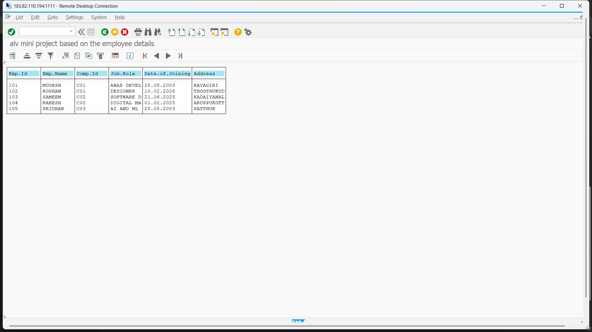
If user click the company id then go to the secondary list(company details)